Vicki Haigh

St Brendan's Sixth Form College

Progress to success session 2: Revision Strategies

**Activity 1: The revision questionnaire**

We’ve found there’s a strong link between the kind of revision someone does, and the outcomes they get.

Which student will do better in an exam?

• Student 1 does fifteen hours revision – all of it reading through class notes.

• Student 2 only does ten hours revision – two hours making mind maps, two hours creating flashcards of key terms, three hours writing timed essays, two hours collecting together all the past papers and looking for patterns in the questions asked, and half an hour doing the hardest question they could find, followed by half an hour with their teacher talking it through. **Then they spend five hours shopping with their friends and watching TV**.

You too can make less mean more. Try this questionnaire:

Name:

1. How many hours independent work do you do on your subjects outside of class? Please state the time spent on each subject.

* Bfgvb
* Vbxvbxxcv
* Cvbxvb

1. What sort of activities do you do? Use the table below:

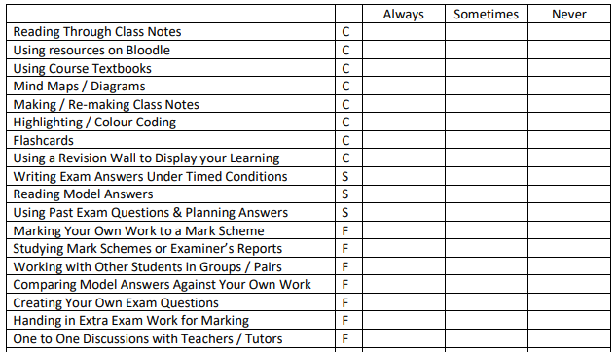

1. **Additional activities not mentioned above:**
2. **Write a brief account of what you do if you can’t understand something. (Try again, read textbooks, see teachers, see other students…)**

You’ll notice some activities have a ‘C’ next to them. **These are the CONTENT techniques.** Notice in our example, student 1 just does CONTENT revision.

Some activities have an ‘S’ next to them. **These are the SKILLS techniques**.

Others have an ‘F’ next to them. **These are the feedback techniques.**

In the example above, student 2 does all three stages of revision, then takes some time off.

Research tells us that student 2 will pretty much always get a better grade than student 1. And they put fewer hours in.

SUMMARY: ***Make sure you do some revision for each of C, S and F***

**Activity 2: High vs Low Utility techniques**

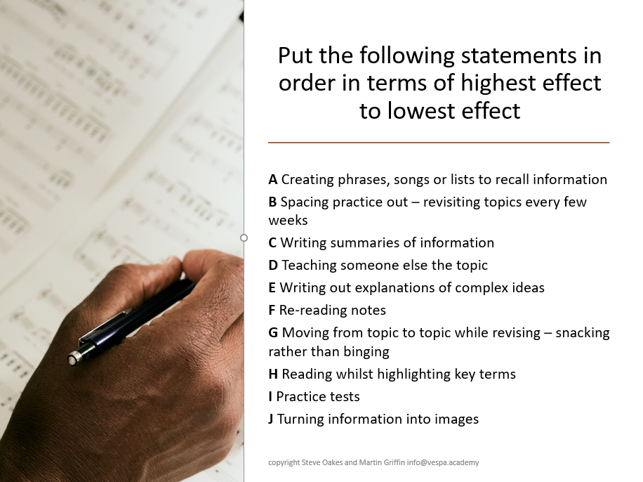

Professor of Psychology John Dunlosky (Kent State University, 2013), has closely examined a wide range of practice techniques, then seen what impact they have on student performance.

Those techniques that seem to have only a weak connection with getting a good grade, he calls ‘low utility’ techniques. These are necessary at times, but only have a small impact on success. Others he classifies as ‘moderate’ or ‘high’ utility.

**The latter are the techniques that seem to have a very strong association with good exam performance and good grades.**

His findings are on the table overleaf

• Which ones are you routinely doing a lot of?

• Which ones do you try ‘rarely’ or ‘never’?

• Choose one technique that is moderate or high utility and try and break it down into steps.

***What things might you have to do in what order to use the technique effectively?***

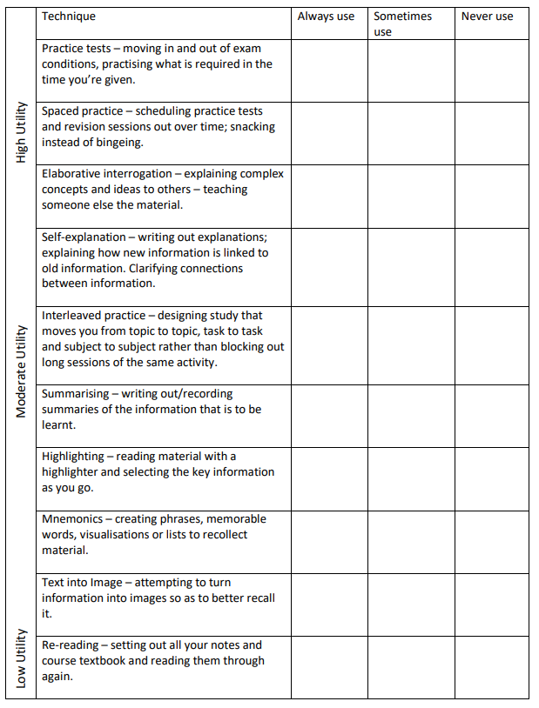

**Activity 3: Verbal Recaps**

This tool is a habit-changer which will very quickly boost your understanding. Of all the activities here, it’s the one that takes only a little effort but can yield big results – so it’s well worth a try next time you have something you need to read through.

Here’s what you do. Every time you read a page of a textbook or study guide, stop and then:

1. Close the book.

2. Calm your mind for a second and think – *what did I just read?*

3. Now talk aloud, summarising in your own words exactly what you’ve just been reading.

Choose one of these starters to get you going if it helps:

* “The writer has just been explaining that…”
* “This section explores…”
* “The important idea here is that…”
* “This page outlines the importance of…”
* *“The writer’s argument here is that…”*
* “I’ve been reading about how…”
* “I’ve learnt that…”

4. If you can’t summarise it clearly…there’s been a problem. Not to worry. Go back and read the section again, and repeat step 3.

5. Once you’re happy you can summarise the content, try asking and answering more complex questions; not ‘what’, but ‘why’ or ‘how’. Try these:

* “*Why is this section important?* Because…”
* “*Why has it been included?* Well, it’s crucial because…”
* “*Why is this bit detailed… or why isn’t it detailed?* I guess it’s because…”
* “*Why is the information in this order?* The writer covers this first/second/third because…”
* “*How does it relate to the previous section?* It’s linked in the following way…”

Reading like this means you go slower. But it means you’re testing yourself as you go along. Try adding spoken summaries of whole chapters, verbally once you’ve read them, like this:

* “First, the writers explore….”
* *“…then they go on to argue that….”*
* *“….then they look at -------- in more detail, explain how….”*
* *“And they finish by concluding that….”*

You’ll find that the information you read goes in. It sticks, and it’s easier to recall. Your reading might have taken a little longer, but you’ve been able to fully explain what it is you’ve just read.

**Activity 4: Test your future self**

There are a vast array of academic studies in which researchers have found that one of the all-time superstars of revision techniques is to test your recall. Sometimes this is called active recall – a technique where you deliberately strain the muscles of your memory by trying to remember things you’ve studied without referring to your notes.

But who sets these tests and where are they? It can be a pain trying to track down tests or search online for just the right kind of test. Instead, we’re going to suggest you set yourself the tests.

Hang on, you might be thinking, if I’ve set the test won’t I know the answers straight away?

Good point. It’s a problem. But here’s how to get around it. At the end of a period of study, the last thing you should do is set a test for your future self. It should take about ten minutes, and it’s a really valuable way to finish a session. By the time you return to the topic a few days or even weeks might have passed and you’ll have forgotten precisely what it was you put in your test. But because you’re the one who set it, you’ll know the test covers the material perfectly.

**What Should Your Test Look Like?**

Mostly that’s up to you, but we’d make the following suggestions:

1. Use the question, “If my future self recalled this material perfectly, what would they know?” and make a list of the things to include in your test.

2. Start with easy questions and move on to harder ones. Leave the toughest questions until last. These can be the questions that might build on all the others.

3. Consider asking definition questions early, using the words “What” or “when” to start your questions. Get the basics sorted.

4. Think about moving towards harder question-words as you go along. “How” or “Why” will require your future self to do some explaining, so leave those until the end.

5. Consider finishing with a tricky question which replicates something a real exam might ask you.

6. Make a note of what kind of test-score would make you happy with your future self. It doesn’t have to be 10/10 – maybe you’ll be pleased if you score 7 or above.

And that’s it – ten minutes’ work that means the next time you revisit this topic, you can begin with a ready-made test to check what you remember.

**Two other things to consider when using this method:**

* Make a note of your score when you first complete a test. Then come back to the topic again – maybe a week or ten days later – and retake the test. If your score is improving, you can start to feel more confident about that topic.
* If you revisit a topic and you’re scoring really well on recall, you can leave it for a while and prioritise those topics where you’re not doing so well. Or if you’re feeling brave… you can design an even harder test

**Activity 5: Closed book notetaking**

Two psychologists working in Indiana in the US studied four revision techniques and their impact on test performance. 80 volunteer students were split into four groups before the test:

**1. Single-reading study.** In this group, students had to read a chapter once.

**2. Repeat-reading study.** In this group, students had to read a chapter four times.

**3. Mind-mapping**. In this group, students read the text once, summarising it in a mindmap.

**4. Active recall**. In this group, students read the text once, then covered it up and tested their recall by writing out as much of it as they could remember in two practice tests.

There were two types of question asked in the test, mixed up so the students didn’t know what to expect.

1. Question type 1 were ‘recall questions.’ Students had to answer simple questions about the information that had appeared in the text.
2. Question type 2 were ‘inference questions.’ These questions were harder, asking students to connect ideas and concepts, requiring deeper knowledge.

Now guess which techniques yielded which results! (Answers over the page…) For the simpler recall questions:

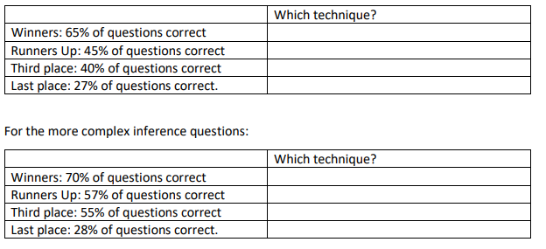

The same technique won both times: **active recall**.

It was the technique that the students thought would work least-best of the four, but in fact it worked the best of the four! It just goes to show that our instincts about revision are often wrong.

Testing yourself will lead to better performance than re-reading notes four times. Think of the time you could save.

So active recall is definitely a technique you should add to your studies. A great way of adding active recall to your studies is to try Closed-Book Notetaking. Here’s how to do it:

**Closed-book Notetaking: an active recall study technique in five steps**

First, you’ll need to choose something you want to learn. You’ll need a section of textbook – not too long – or a study guide or some notes you’ve already made. Once you’ve chosen what you’re aiming to learn, here’s what to do:

1. Read the section of textbook/information without taking notes. Really connect and concentrate as you read.

2. Now close the book/put the notes away. If you want, try a verbal recap at this point!

3. Now write notes on the section you’ve just covered without looking at the information! It will feel hard. You might get frustrated. You won’t be able to remember everything. No problem; leave lots of space to add forgotten information. Scatter the notes around the page with subheadings and leave lots of white paper.

4. When you’re done, open the book or turn over the notes. Re-read once, then close the book again. Now note-take for a second time but…

5. …add the stuff you missed or forgot in another colour, filling the white space you left first time around.

And that’s it. This approach will be more effective than reading the material four times. You might even finish more quickly than you would have doing four re-reads.

Of course, it will feel harder than just re-reading. It’s not as comfortable, and you might feel exhausted by the end. But you’ll perform better in tests and exams if you make this part of your weekly study!